**UE Machine Learning: Supervised Techniques**

Exercise 3 Report

Name: Omar Amr

Matrikel-Nr: k11776960

**E(y | ) = f(x0) = 0.6 $({x0)}^{4}$ + 2( ${x0)}^{3}$-􀀀8 $({x0)}^{2}$**

**Var(y | ) = Noise in the data itself = 0.09**

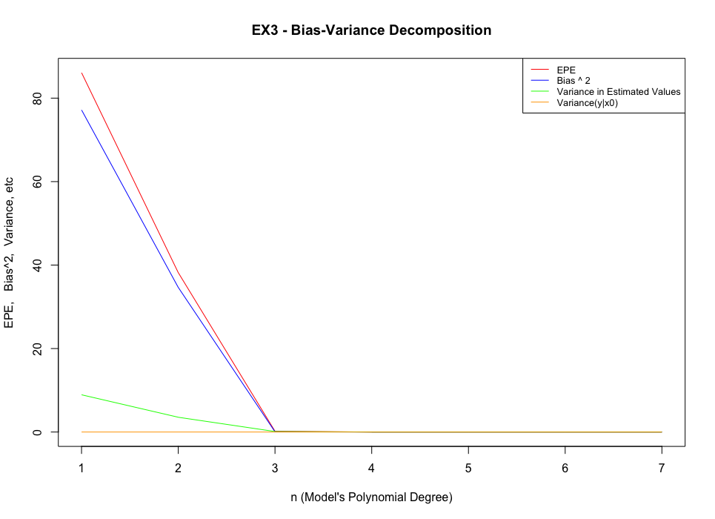

**Results Visualization:**

**EPE Graph Explanation:**

The value of EPE at n=1 shows very high error which indicates that a polynomial model of degree 1 cannot fit the data in a good way. The same applies for n=2, however the error is less than the first case.

For n=3, the model shows a significant decrease in the EPE value which was almost the same for n > 3. This means that a polynomial model of 3rd degree fits the data very well.

For n > 3, the models will fit the data at least as good as n=3 as a model of degree k+1 will at least fit the data as good as model of degree k, however for values of n much greater than 3 the model becomes so complicated that it over fits the data and EPE increases again. Since n was from 1 to 7 only, over fitting cannot be noticed in this case.

**Bias^2 Graph Explanation:**

Bias^2 is a measurement of how close the model approximates the average target at x0. In other terms, it is the square of the difference between the correct value and the average predictions of the model. Low bias values mean that the predictions are very close to the correct value.

This means lower helps to achieve better results. The graph shows that bias has high values at n=1 and n=2, however starting from n=3 the bias value is so low.

**Variance in Estimated Values Graph Explanation:**

The green graph shows the variance between the estimated values for x0 (variance in f(x0)). It represents how the predictions of the same input vary from each other. Low variance means that the model is fitting the data in a better way.

High variance

Low variance

The graph shows that starting from n=3 the variance value is so small. Lower variance and bias values indicate the correctness of the model. It means that the model estimates almost the same values for the same input and also the predicted values are close to the correct values. This explains the low value of EPE at n>3 as the variance and bias at this point is so low.

**Var(y|x0) Graph Explanation:**

This is the variance between the predicted value and the mean of previously predicted values during the training process. The yellow line shows that the value is almost 0 for all n even for lower values of n where the EPE is so high. The only explanation of this behaviour is despite the high error at n=1,2 , the model did not improve its predictions during the training process that the values where always predicted the same way as it was at the beginning of the training. The low values and n=3,4,5,6,7 means that the model was able to fit to the model quickly that the wrong predictions were so little and most values were predicted correctly.